STARTERS & MOMO
HIMALAYAN
CHULO
H
I
M
A
L
A
Y
A
S
A
T
A
S
T
E
O
F

NEPALI THALI


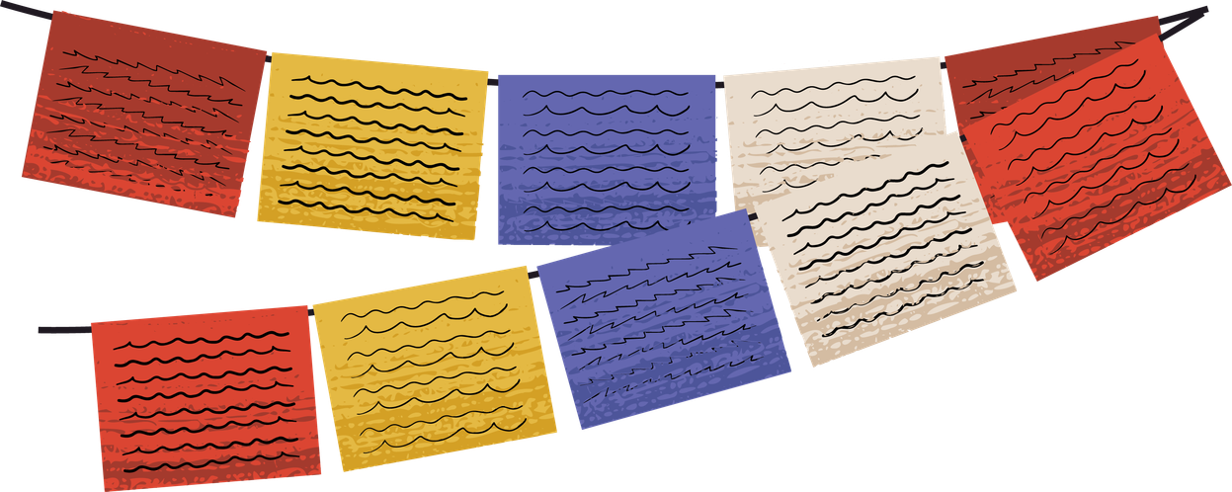
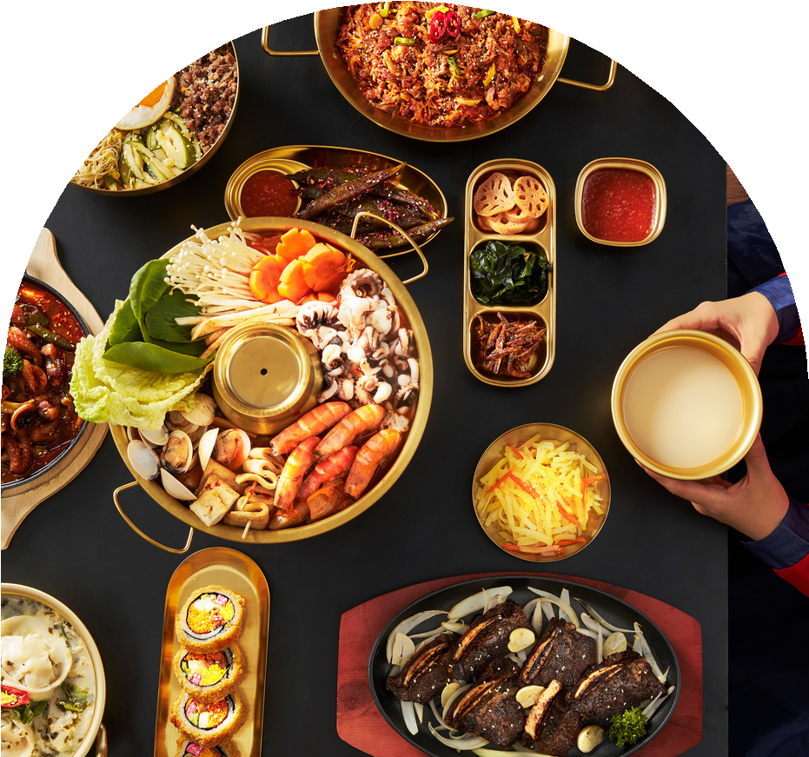

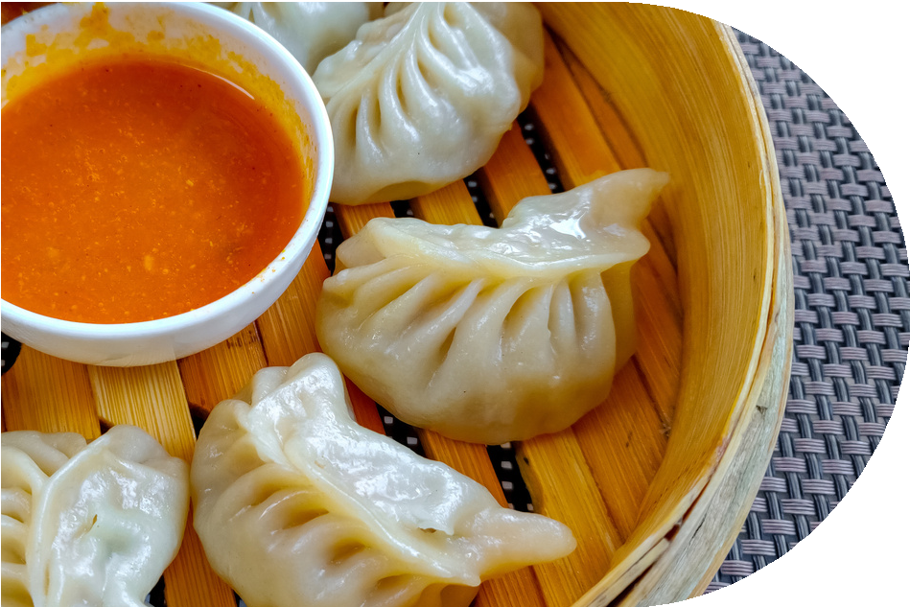
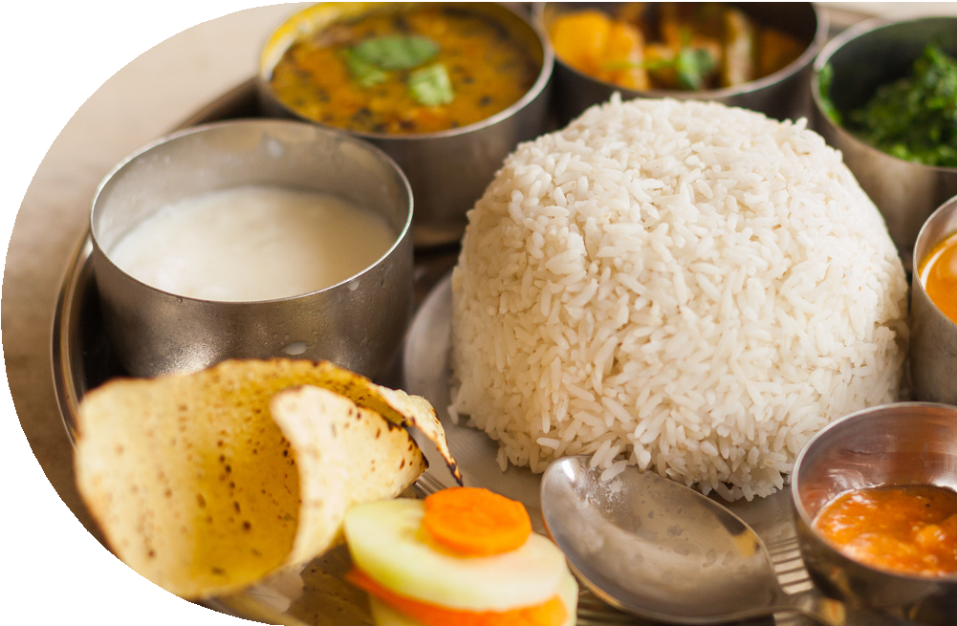
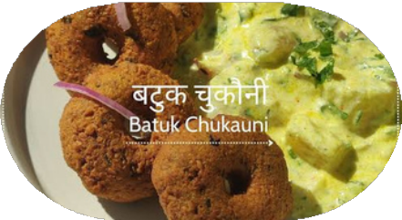
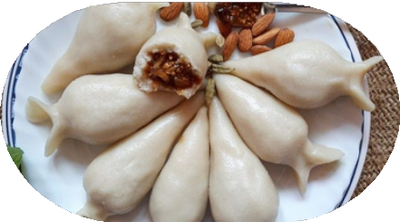



Steam Chicken Momo Chicken Jhol Momo Buff Sekuwa
Pork Sekuwa WaiWai Sadeko

SNACK & SIDES
Selroti & Aloo Bara or Batuk Chukauni Sapu Micha

Rs. 120
Rs. 150
Rs. 140
Rs. 180
Rs. 100

Rs. 100
Rs. 80
Rs. 60
Rs. 50
MENU


Authentic Flavours Warm Hospitality

Chicken Dal Bhat Thakali Khana Set Newari Khana Set Dhido Khana
Veg Khana

DESSERTS
Juju Dhau Khuwaa Yomari Barfi

RS. 300
Rs. 450
Rs. 500
Rs. 350
Rs. 200

Rs. 100
Rs. 60
Rs. 80
Rs. 80

